User Guide 2 Receiving a new application in SPEAR
Purpose of this User Guide
The purpose of this User Guide is to provide assistance to Responsible Authority users about the steps to process their first application in SPEAR.
Who should read this?
Primary audience: Responsible Authorities
For information: Applicant Contacts and referral authorities
Introduction
Accepting a new application signifies that the application is complete enough to enable it to be processed by the Responsible Authority. Accepting an application should occur around the same time the Responsible Authority registers it in the council’s Planning Register.
If the application is missing vital information or has been supplied to the wrong Responsible Authority, it can be rejected. Having accepted the application, the Responsible Authority always has the option to request further information from the Applicant Contact through SPEAR.
  - How will a Responsible Authority know that a new application has been lodged?
There are two ways that a Responsible Authority user can find out about a new application:
- A notification (email) will be sent to the Responsible Authority’s assigned inbox advising that a new application has been lodged for their consideration, or
- Once you login to SPEAR, the initial screen showing the current list of applications at your organisation will display the new application with a status of ‘submitted’ and indicate there are actions required for that application.
The application can be accessed via the SPEAR email notification by clicking on the website link in the email. An internet browser window will open at the SPEAR login screen. After successfully entering their login details, the SPEAR user is directed to the Summary screen of the relevant SPEAR application.
From the Details screen in SPEAR a Responsible Authority user may peruse the application contents including the application forms, the plan and other accompanying documentation by clicking on the name of the relevant documents under the Application Contacts section.
  - What is the difference between a ‘Submitted’ application and one that is ‘Lodged with Responsible Authority’?
A ‘Submitted’ application is one that has been submitted by the Applicant Contact but has not yet been accepted by the Responsible Authority in SPEAR.
An application that is ‘Lodged with Responsible Authority’ is one where it has been accepted and registered by the Responsible Authority, in SPEAR.
Acceptance or rejection is a mandatory action for the relevant Responsible Authority once an application has been submitted through SPEAR.
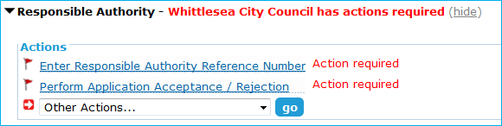
Accepting the application will typically be when Responsible Authorities will retrieve the application details from SPEAR, either printing documents for hard copy files or saving documents electronically to their document management system. The ‘Bulk Download & E-mail’ function in SPEAR makes downloading or printing multiple documents at once faster and easier.
  - How does a Responsible Authority accept an application in SPEAR?
To accept or reject an application, a Responsible Authority user selects the ‘Perform Application Acceptance/Rejection’ action from the Details screen and selects the relevant radio button.
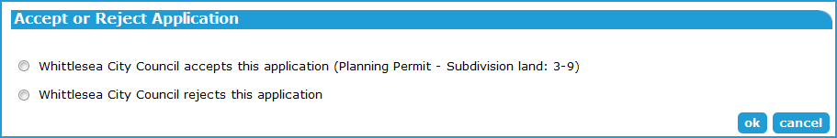

The Responsible Authority still has the option to request further information about the application once it has been accepted.
If rejecting an application, the Responsible Authority must provide a reason for the rejection. The application status will change to ‘Rejected by Responsible Authority’ and the Applicant Contact can re-submit the application with the missing or incorrect information rectified. The Applicant Contact may choose to delete the application instead of resubmitting it.
The applicant will receive a notification email once the Responsible Authority has performed the accept/reject action.

If the application is for a planning permit, the Applicant Contact can indicate whether it meets the VicSmart criteria. The Responsible Authority will be required to confirm or change the application’s Vicsmart status when accepting the application.
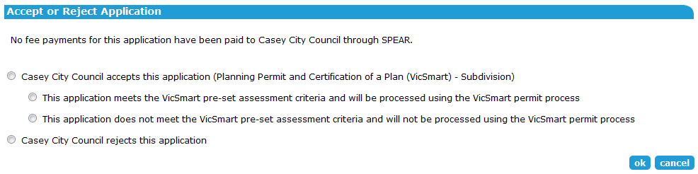

Note: The Responsible Authority can also change the VicSmart status after the application has been accepted using the optional action ‘Modify Application Document Details’.
  - When will a Responsible Authority accept a new application?
The trigger for a Responsible Authority to register and accept the application may vary for each Responsible Authority based on their individual policies, particularly relating to if they will register an application without the statutory application fees having been received.
  - How do you add a reference number and a responsible delegate?
Once the Responsible Authority has accepted a new application, they need to add the Responsible Authority’s reference number. This enables the Responsible Authority and other users to search for the application using the Responsible Authority reference number.
As part of the action to add reference numbers, the application can be assigned to a Responsible Authority staff member or ‘Delegated Planning Officer’. The Delegated Planning Officer is assigned by selecting from a drop-down list of all delegated planning officers organisation (who have been granted access to SPEAR) in the organisation.
Need more information?
Further information on this topic can be found by:
- Visiting the SPEAR website www.spear.land.vic.gov.au/SPEAR
- Contacting the SPEAR Service Desk on 9194 0612 or email spear.info@delwp.vic.gov.au
- Selecting the Help link in the relevant area of the SPEAR system.

